GRADE 7 ACCELERATED · UNIT 2  Unit 2 Review  Real Numbers, Square Roots and Cube Roots — 41 questions | Name_________________________  Date__________________________  Period________________________

HOW TO USE THIS. This review covers every learning target from all six lessons of Unit 2 — more than the assessment does. Work it in parts. If you miss two or more in a part, that part is where to spend your study time. The reference sheet has everything you need for each part.
PART A. Square Values and Square Roots
Lessons 1 and 2 · 9 questions
1. List every perfect square from 1 to 225.

2. Evaluate. 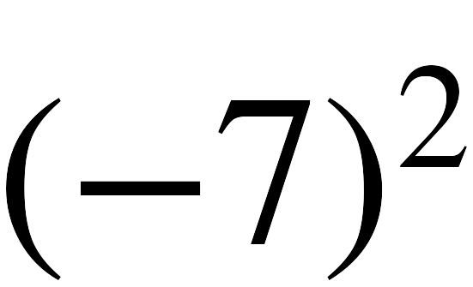

3. Evaluate. 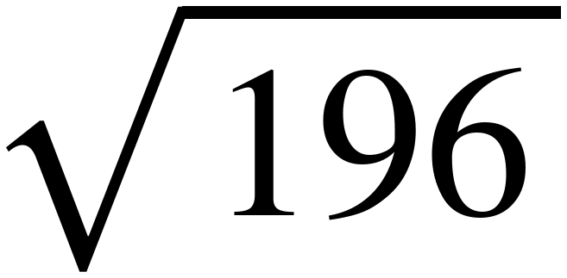

4. Evaluate. 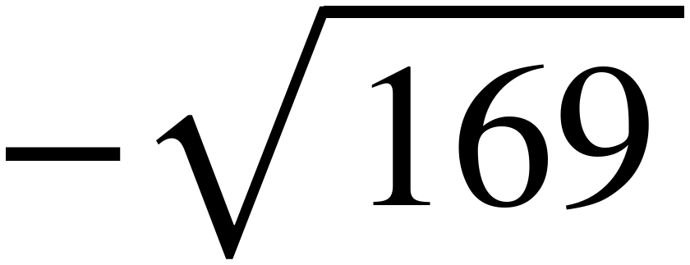

5. Evaluate. 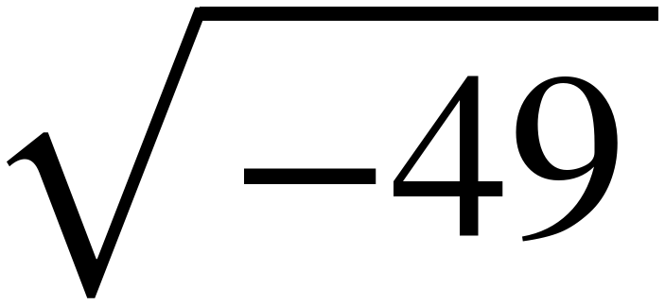

6. A square patio covers 144 square feet. How long is each side?

7. Explain the difference between 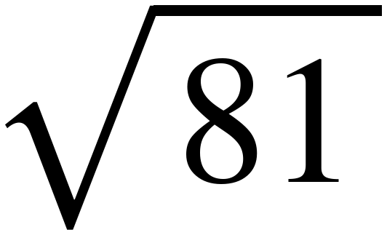 and the solutions of 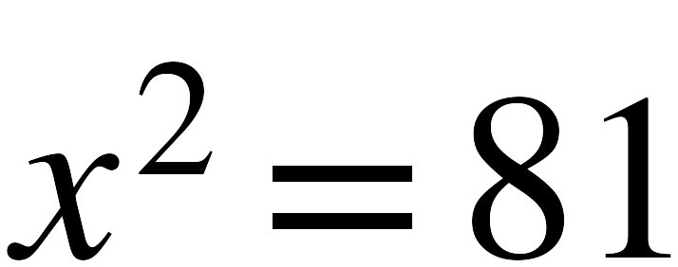 .

8. True or false: 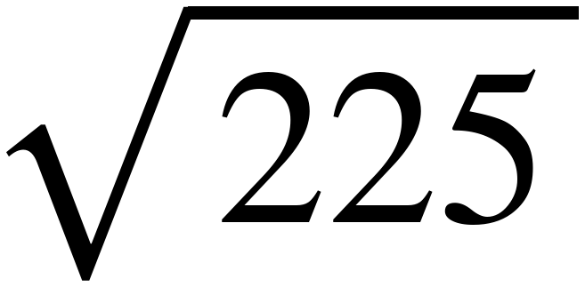 = 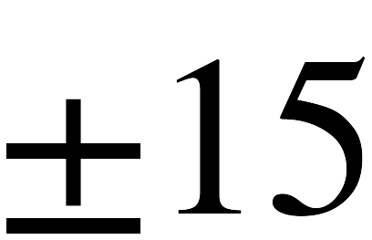

9. Every part below is about 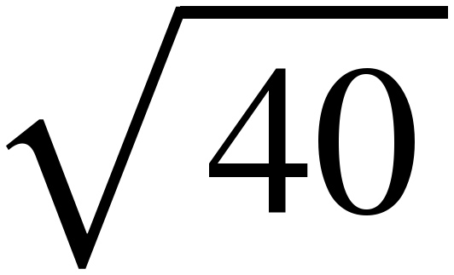 .
a. Between which two consecutive integers does lie, and which is it closer to?

b. Is rational or irrational? How do you know?

c. Solve 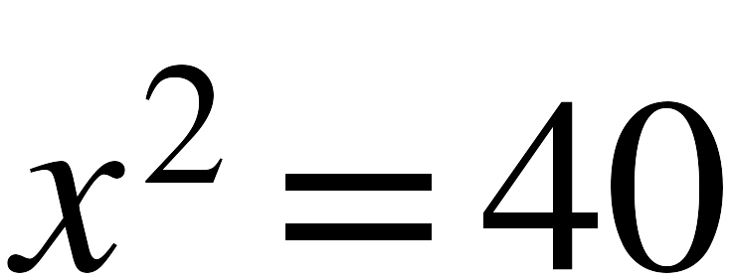 . How many solutions does it have?

d. ≈ 6.3. Explain why × is exactly 40 but 6.3 × 6.3 is not.

PART B. Cube Values and Cube Roots
Lesson 3 · 6 questions
10. List every perfect cube from −125 to 125.

11. Evaluate. 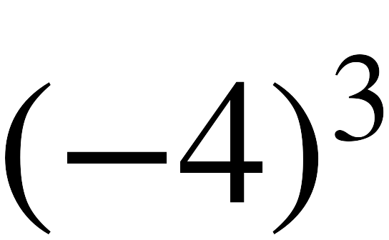

12. Evaluate. 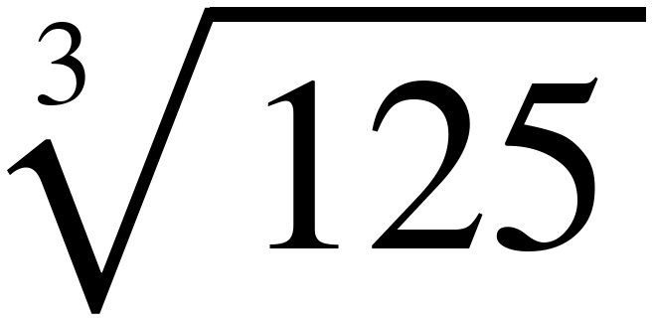

13. Evaluate. 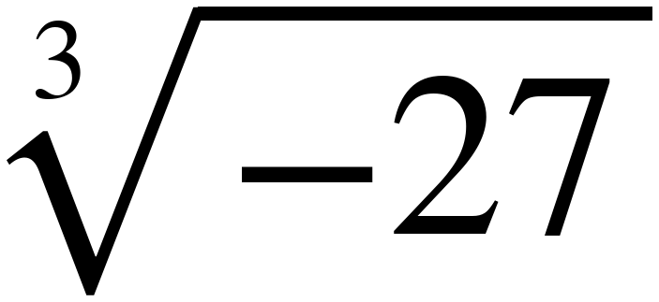

14. A cube holds 64 cubic centimeters. How long is each edge?

15. Why does 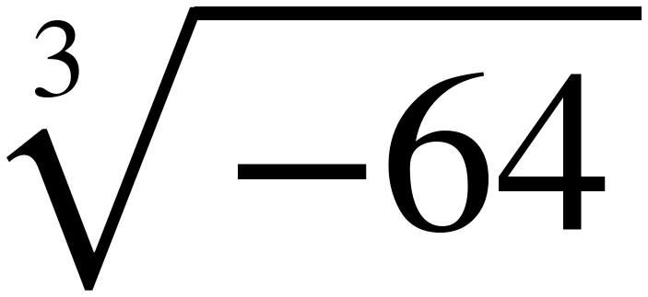 have a real value while 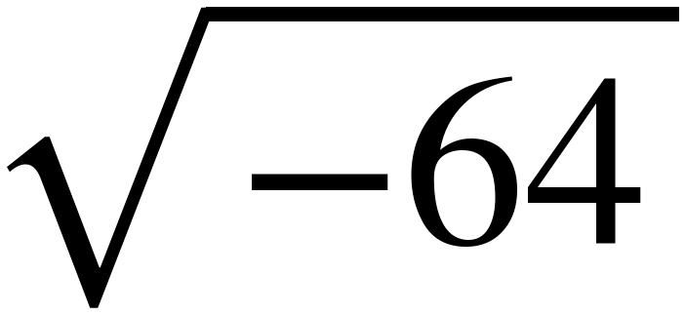 does not?

PART C. Solving x² = p and x³ = p
Lessons 2 and 3 · 6 questions
16. Solve. 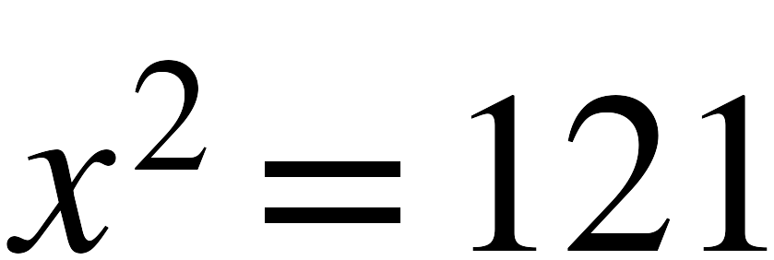

17. Solve. 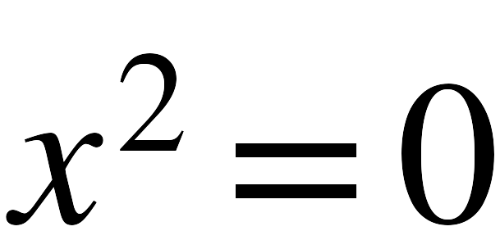

18. Solve. 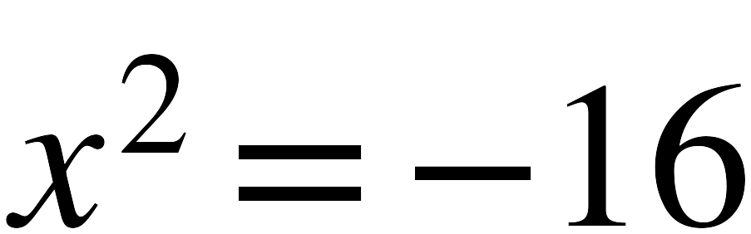

19. Solve. 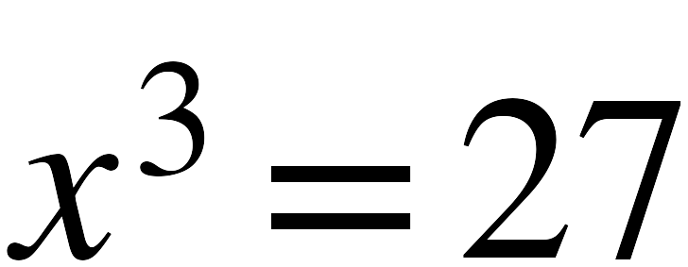

20. Solve. 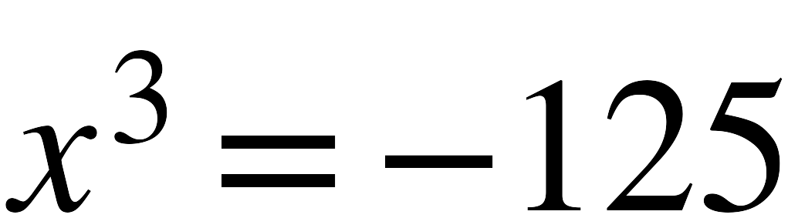

21. Select all of the solutions of 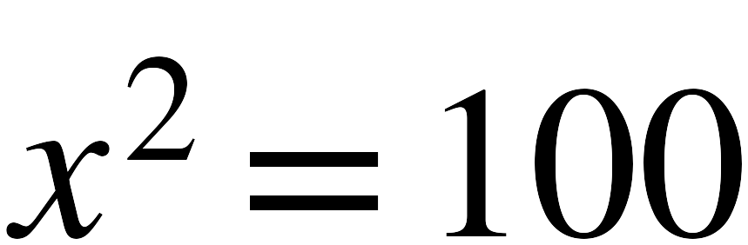 .
☐ | 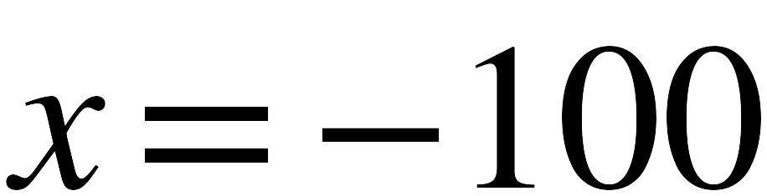 | ☐ | 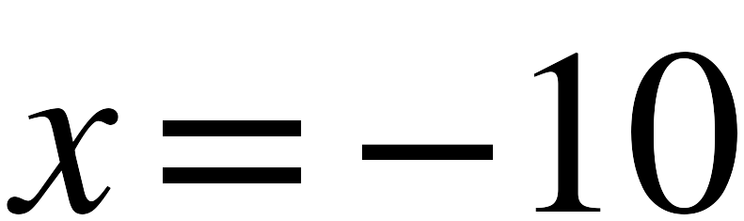 | ☐ | 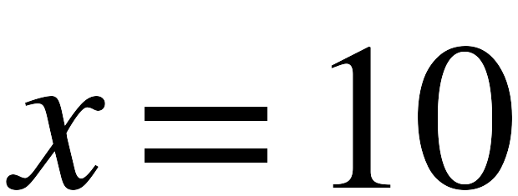
☐ | 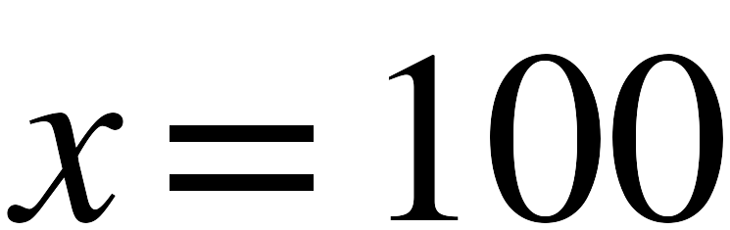

PART D. Approximating Irrational Numbers
Lesson 4 · 6 questions
22. Between which two whole numbers does 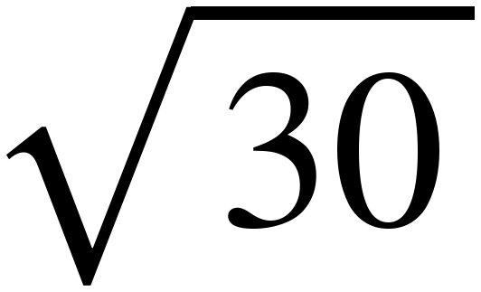 lie? Which is it closer to?

23. Between which two whole numbers does 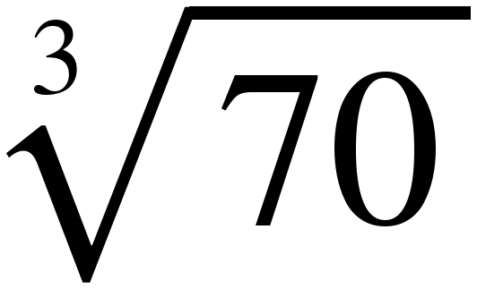 lie? Which is it closer to?

24. Approximate 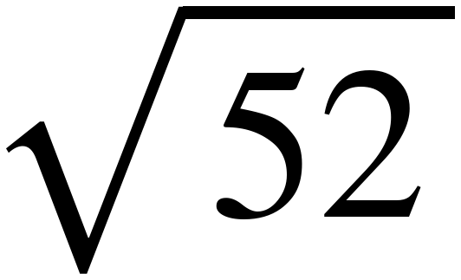 to the nearest tenth.

25. Approximate 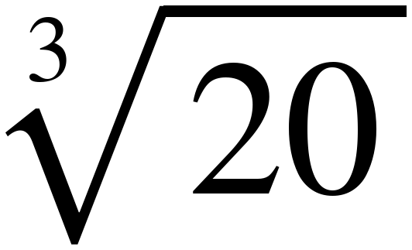 to the nearest tenth.

26. Approximate 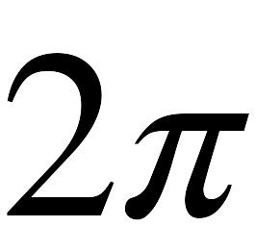 to the nearest tenth.

27. Dev uses 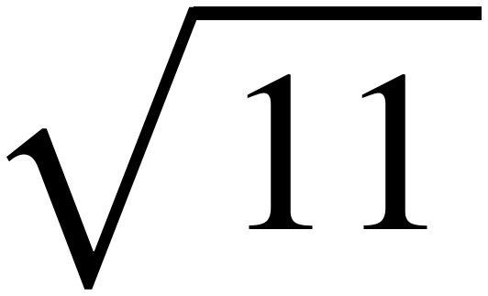 ≈ 3.3 to approximate 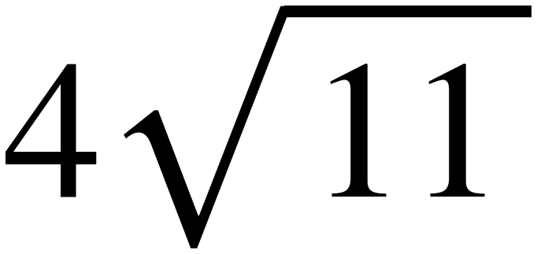 and gets 13.2. A calculator gives 13.3. What went wrong?

PART E. Rational or Irrational
Lessons 4 and 5 · 6 questions
28. Is 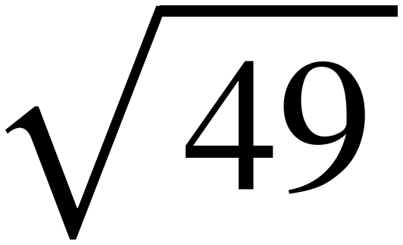 rational or irrational? Explain.

29. Is 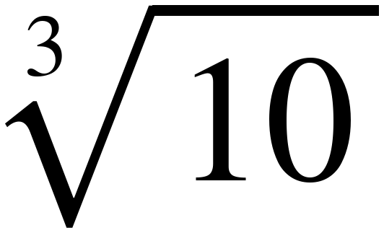 rational or irrational? Explain.

30. Is 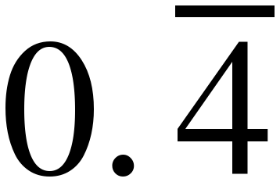 rational or irrational? Explain.

31. Is 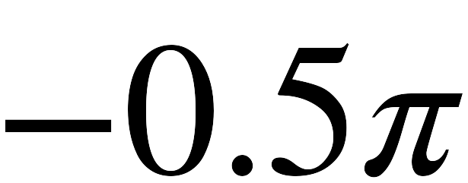 rational or irrational? Explain.

32. Is 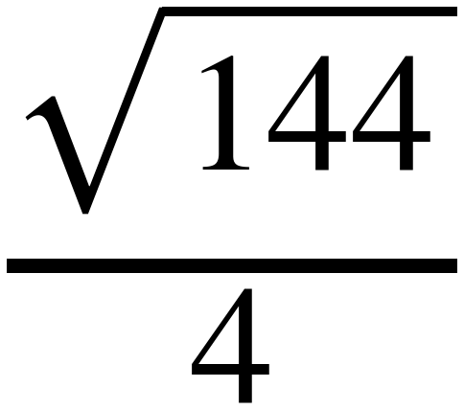 rational or irrational? Explain.

33. Sort the six numbers into the table.
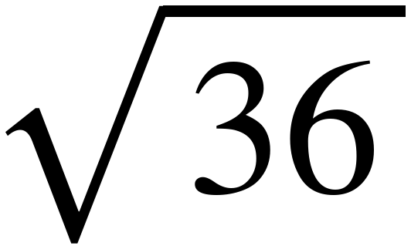 , 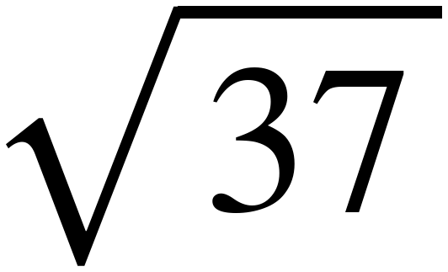 , 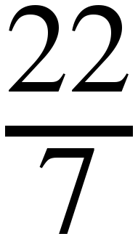 , 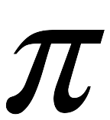 , 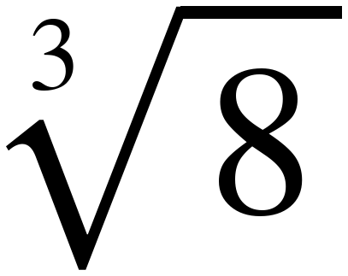 , 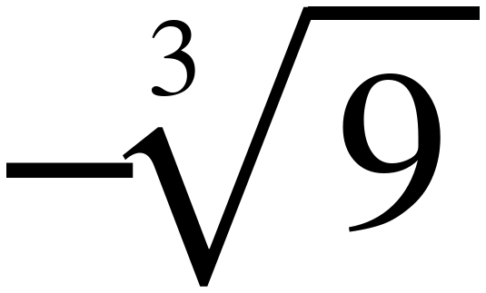
Rational | Irrational

PART F. Plotting, Ordering and Comparing
Lessons 5 and 6 · 8 questions
34. Order from least to greatest. 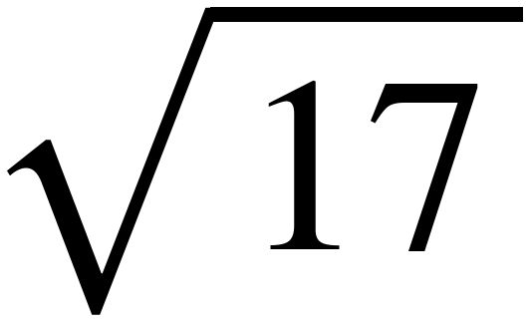 , 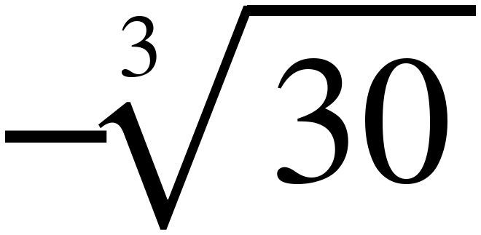 , 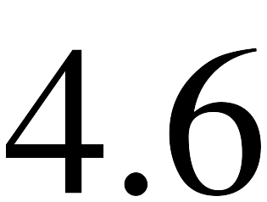 , 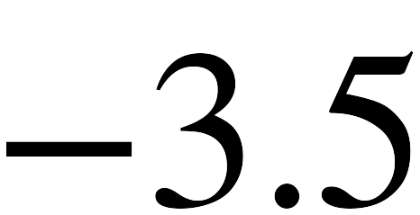 , 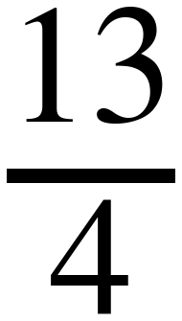

35. Order from least to greatest. 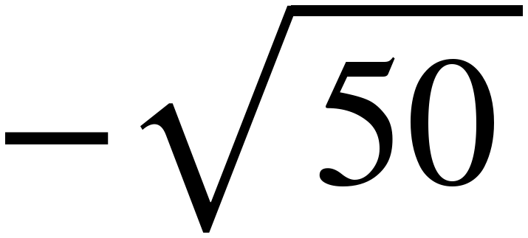 , 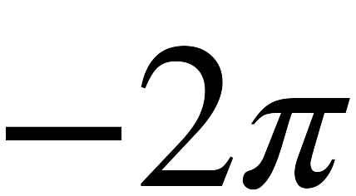 , 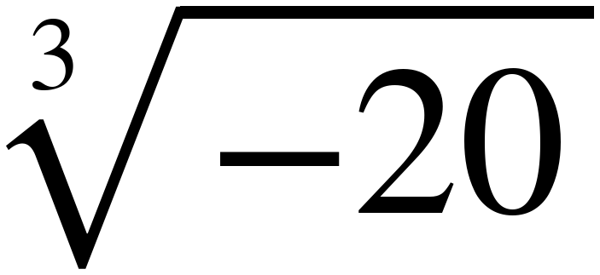 , 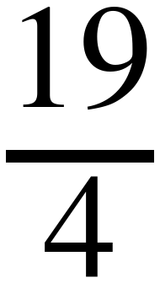 , 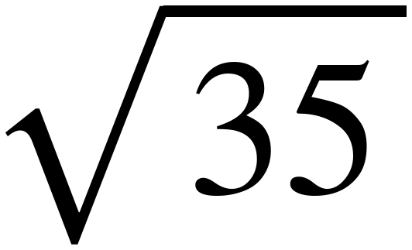

36. Compare using <, > or =. 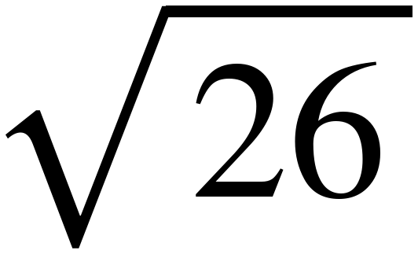 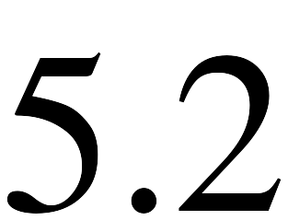

37. Compare using <, > or =. 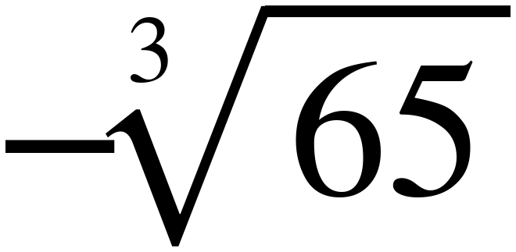 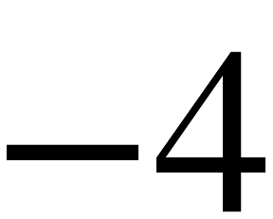

38. Compare using <, > or =. 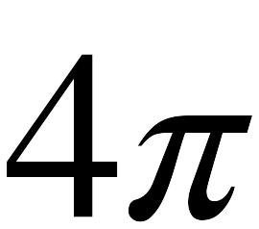 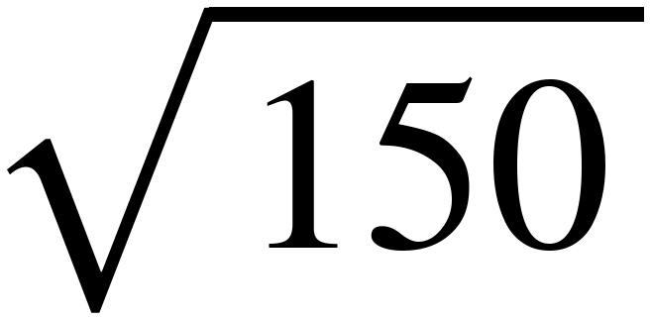

39. Compare using <, > or =. 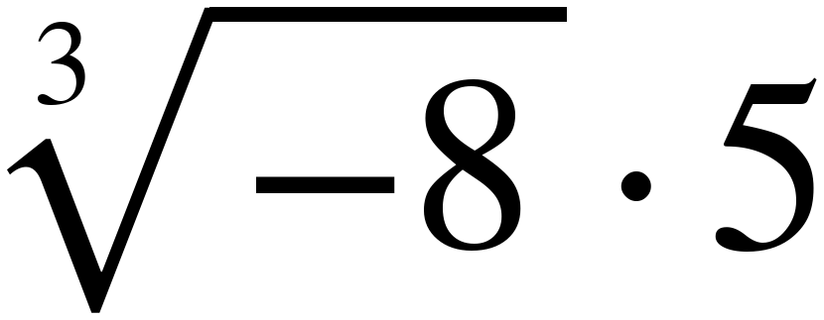 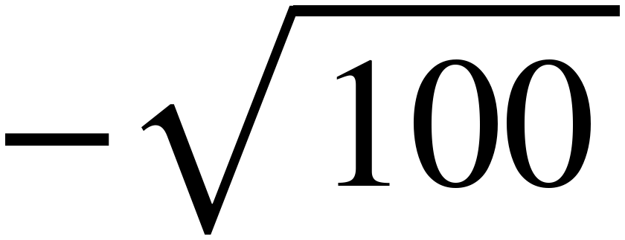

40. Plot and label each value. 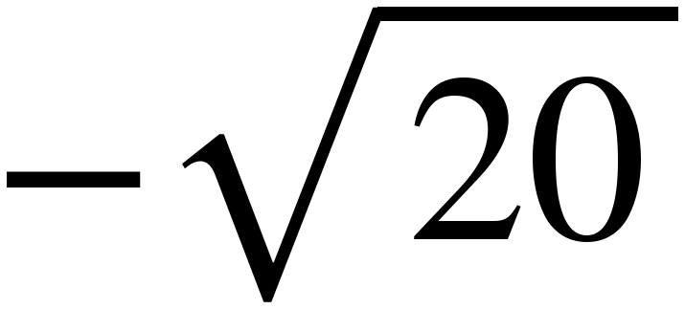 , 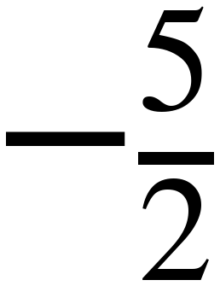 , , 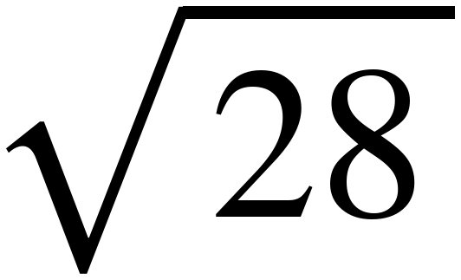

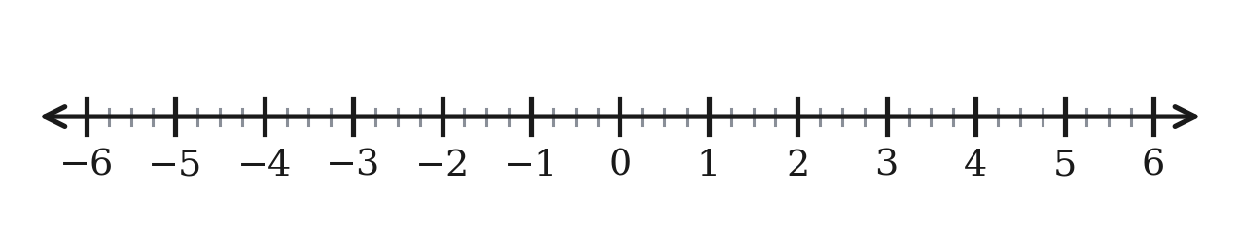

41. Marcus orders , 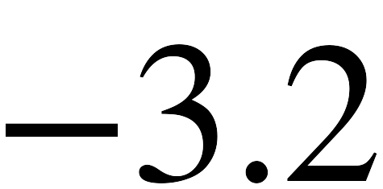 , 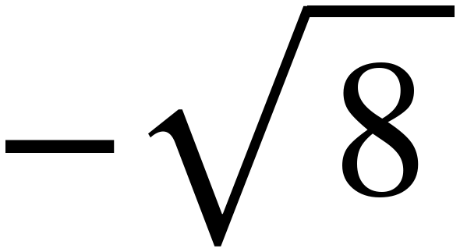 from least to greatest and writes , , . Is he right? If not, fix it.

